**Bidirectional rnn:**

Till now we have seen uni-directional Rnn i.e later outputs can depend on current input or previous input. But what if current output i.e y13 depends on latter inputs i.e x15 for this we use bidirectional rnn.

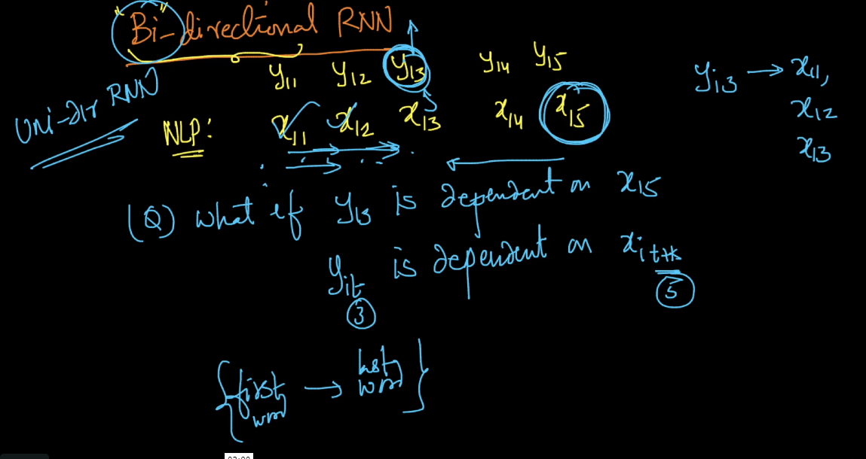

In this we have two layers forward layers (blue blocks)and backward layers (green blocks) forward layer are similar to those we have seen earlier.

And In backward layer input is given in reverse sequence i.e in first block we give xi4 and so on.

For time respective things see below comments.

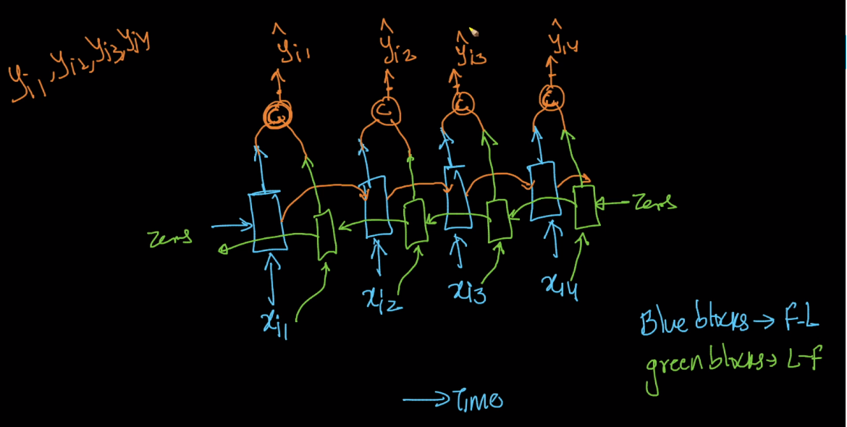

Below image shows that using forward blocks output yi3 is dependent on xi1, xi2, xi3 and by using backward blocks output yi3 is dependent on xi4.

For forward pass we use direction of arrows and for backward pass it uses reverse direction of arrows.

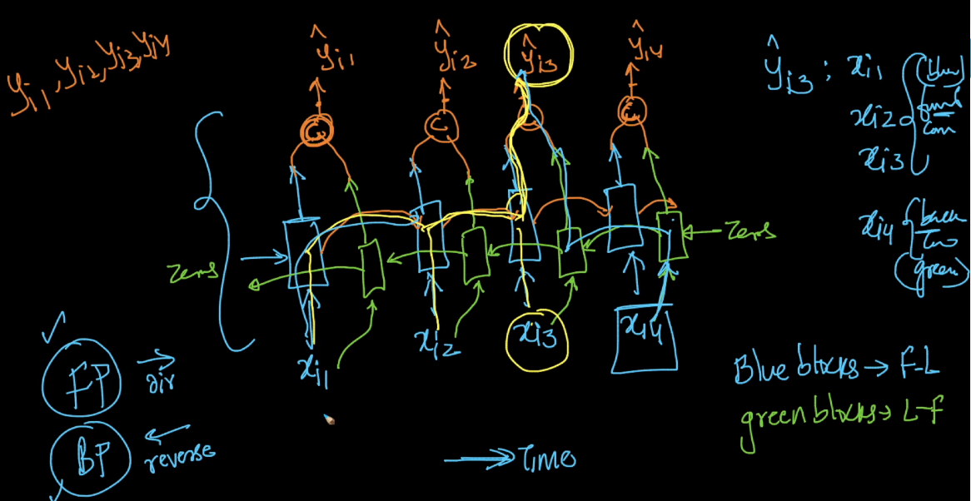

Bi-dir Rnn is very useful in nlp tasks like language translation because outputs can depend on later inputs but in this first we have to feed full sentence then only last word goes in first block of backward layer.

Speech translation but for this first all audio have to feed like nlp text we have seen before.

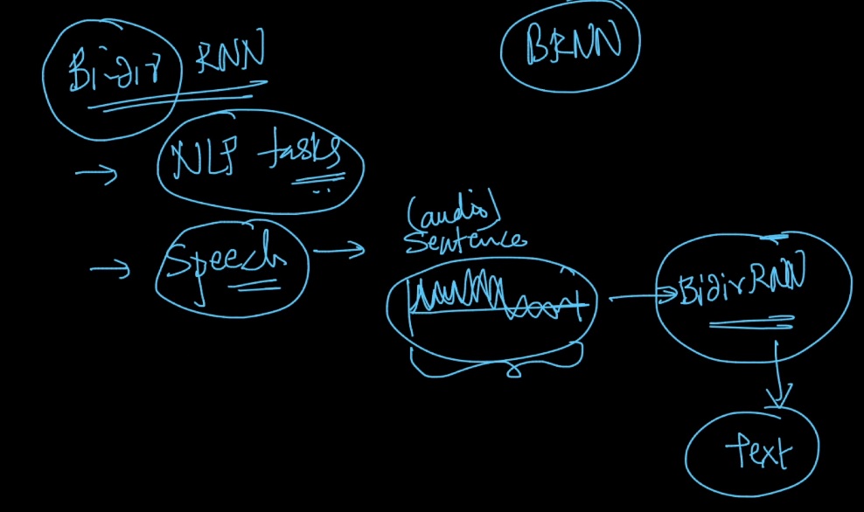

Links :

https://arxiv.org/abs/1810.04805  
https://towardsdatascience.com/transformers-141e32e69591  
https://towardsdatascience.com/word-level-english-to-marathi-neural-machine-translation-using-seq2seq-encoder-decoder-lstm-model-1a913f2dc4a7

**Comments :**

